Instructions for use are available on the Website, print instructions out before commencing.
Xmas report template 2 (delete this guide)
(This standard template is setup for 3:2 aspect ratio photos) (delete this guide)
All the other row sizes can be found at the bottom of this template) (delete this guide)

Combined Probus Club of Wheelers Hill
Christmas Lunch dd December yyyy
Photographs and commentary courtesy NNNNNNNN
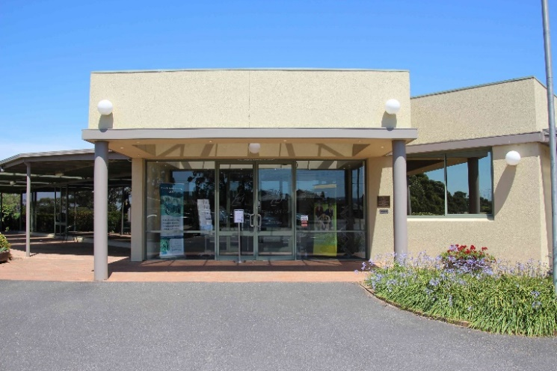 | 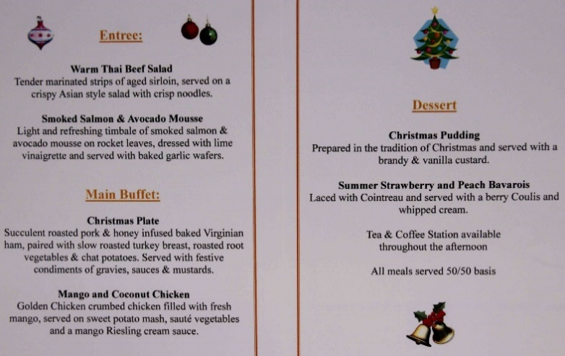
Luncheon venue - Waverley Golf Club | Lunch Menu

Change pictures as required. (highlight picture with curser / right click /select change picture)
Main description text goes here (delete this guide)

Insect Caption. | Insect Caption.
Insect Caption. | Insect Caption.
Insect Caption. | Insect Caption.
Insect Caption. | Insect Caption.

Insect Caption. | Insect Caption.
Insect Caption. | Insect Caption.
Insect Caption. | Insect Caption.
Insect Caption. | Insect Caption.

Cut and paste more table rows here (delete this guide)
(If unsure how to do this refer to Template instructions) (delete this guide)

Leave the following black text (delete this guide)
Expand photos using your browser ZOOM feature or with your fingers in the normal way on your phone or tablet.
****

Alternative tables to match exactly match aspect ratio of photos
(Create the tables before inserting photos)
(See template instructions section 5 Optimising the template to match the aspect ratio of the photos, delete these tables when document is complete)

3:2 Aspect ratio table row
Cameras using an aspect ratio of 3:2. (ratio 1.5)
Digital SLR’s and some compact digital cameras.
Column width 9 cm, Row height 6cm. (All columns must be the same, do not make columns > 9)
Picture width 8.75cm, picture height 5.8cm. (ratio 1.5)
Cameras using an aspect ratio of 3:2. | Cameras using an aspect ratio of 3:2.

4:3 Aspect ratio table row
Cameras using an aspect ratio of 4.3. (ratio 1.33)
Digital SLR’s and some compact digital cameras.
Column width 9 cm, Row height 6.75 cm. (All columns must be the same, do not make columns > 9)
Picture width 8.75cm, picture height 6.58cm = 1.329 ratio
Cameras using an aspect ratio of 4:3. | Cameras using an aspect ratio of 4:3.

16:9 Aspect ratio table row
Cameras using an aspect ratio of 16:9. (ratio 1.77)
Digital SLR’s and some compact digital cameras.
Table Column width 9cm, Row height 5. (All columns must be the same, do not make columns > 9)
Picture width 8.75 cm, height 4.95cm. (ratio 1.767)
Cameras using an aspect ratio of 16:9. | Cameras using an aspect ratio of 16:9.

20:9 Aspect ratio table row
Cameras using aspect ratio of 20:9. (ration 2.22)
Extra Wide screen mobile phones.
Column width 9 cm, Row height 4 cm. (All columns must be the same, do not make columns > 9)
Picture width 8.75cm, Picture height 3.95cm. (ratio 2.215)
Cameras using an aspect ratio of 20:9. | Cameras using an aspect ratio of 20:9.

